HomePage
Feature | Existing Status and WorkFlow | Updation and improvement
Header “VidyuSaathi” | Naming the application as VidyuSaathi as a helper and supporter for the electricity
Mahavitran Image with application info | Telling this application is solely belongs to Mahavitran | The image is not completely covered
Application HomePage UI | User friendly for easy handling | Update it for more Visuals
User Login Button | Single button For User login | -
Citizen Registration Button | Single button for registration | -

Login Window
Feature | Existing Status and WorkFlow | Updation and improvement
Login As Selector Box | It consists of:  - Citizen  - Officer  - Officer Designation  - JE (Junior Engineer)  - AE (Assistant Engineer)  - DYEE (Deputy Executive Engineer)  - EE (Executive Engineer)  - SE (Senior Engineer)  - CE (Chief Engineer)  - Admin  - ADMIN  - IT ADMIN | Add Field Engineer position before the Junior Engineer and create related screen and specify the officer role.
Email Section | Entering the Email ID and validating it with database or auth credentials
Password Section | Entering the Email ID and validating it with database or auth credentials
Sign In Button | You will be logged in the systema by validating with the credentials
Sign Up Button | You will see the Registration window for the citizen, Officer and Admin.

Registration Window
Feature | Existing Status and WorkFlow | Updation and improvement
Role Selector | It consists of:  - Citizen  - Officer  - Select Role  - Officer Designation  - Select Office  - Admin  - Select Role
Full Name | Name of the User
Phone Number | Mobile Number of the User
Email | Email of the User
Address | Address of the User
Consumer Number (Optional) | Consumer ID on the electric bill
Password | Password of the User
Confirm Password | Confirmation for the password
Create Account Button | Creating account by storing the details in the database

Citizen Dashboard
Feature | Existing Status and WorkFlow | Updation and improvement
Report Issue Button | User will enter an issue. On clicking, it will redirect to complaint details screen | -
Issue Title Button | Heading (Title) of the issue  Short description of issue | Remove the ML pipeline from the Title to description. Update it with the dropdown section
Issue Description Button | Detail description of the problem | Store it in the database for reflecting it to user.
Location Button | Fetching the location using Google API | -
Attach Images Button | Capturing live images in base64 format | Store it location at the corner.
Submit Button | Sending it to the ML pipeline and storing in the database.  If the ML server is on, it will use it or use an fallback mechanism to store the ticket.
My Reports Button | All complaints with labels like In progress, resolved, etc. and categories like low/high/medium/critical that are enlisted will be reflected and on clicking the individual report a detailed version will open.(described below)
Individual issue (ticket) | Consist of:  - Reporter Details  - Name  - Phone  - Issue Details  - Category  - Description  - Reported On  - Last Updated  - Location  - Attached Images | Update the location which is currently OpenStreetMap based with google api
Recent Reports | Shows the 3 recently stored issue(tickets) from all the complaints of the database | THINK AND ASK.  Make it user specific.
Notification Button | Currently, only assignment message is coming that is generalized with only Issue Title name with date  Note : The blue dot show it is unseen and not read | Update it properly by various phases of completion and status update
Mark as Read | Currently Not working  It will set all the messages as read and all the complaints that are been stored in the database is coming here. | Make it user Specific.
Sidebar | It Consists of:  - Dashboard  - Report Issue  - My Reports
Logout Button | Working Logged out from the application

Officer Dashboard
            - Junior Engineer Dashboard
Feature | Existing Status and WorkFlow | Updation and improvement
SCADA Verification Panel Flyer  NOTE: Mahavitran haven’t mentioned anywhere that they used SCADA system on the online. Internally, It may be there but it is difficult for us to get them update of the hardware system like Power lines, etc. on the mobile app for now | The SCADA (Supervisory Control and Data Acquisition) Verification Panel serves to:  - Monitor Critical Infrastructure - Allows JEs to verify the status of electrical distribution infrastructure in real-time  - Field Operations Support - Provides quick access to essential system metrics needed for field work verification  - Operational Readiness Check - Ensures all critical systems (feeders, substations, weather) are operational before assigning field tasks | 1. Feeders Card - '12/15'  - Displays: 12 active feeders out of 15 total  - Purpose: Shows power distribution line status  - Icon: electrical_services (⚡)  2. Substations Card - '8/8'  - Displays: 8 operational substations (all online)  - Purpose: Confirms all transformation stations are functional  - Icon: power (⚡)  3. Weather Card - 'Clear'  - Displays: Current weather condition  - Purpose: Helps assess field work safety conditions  - Icon: wb_sunny (☀️)
Today’s Field Work Section | It will give him (JE) the idea of the today’s task with the realtime percentage of completion and the area in which it is going on. | One approach can be taken that the field Engineer can update the status that can be reflected it here and verified further.
My Tasks Button | To redirect it to Task Management Section
Sidebar | It consists of:  - Dashboard  - All tickets  List of all complaints with a search bar  - Task Management  Explained below  - Reports  - Daily Summary  - Weekly Analysis  - Monthly Report  - Team Performance  - SLA Compliance | Currently all the report tabs are not working  Ideal functionalities are enlisted below  Daily Summary  - Performance Metrics  - Tasks Completed: 5  - Tasks In Progress: 2  - Pending Tasks: 3  - Overall Completion Rate: 62.5%  - Time Analysis  - Total Hours Worked: 8.5 hrs  - Average per Task: 1.7 hrs  - Most Time-Consuming Task: Fault Repair (3.2 hrs)  - Most Efficient Task: Meter Reading (0.9 hrs)  - Cost Breakdown  - Materials Cost: ₹2,450  - Labor Cost: ₹1,020  - Total: ₹3,470  - Task List  - Expandable list of all tasks with status  - Field Observations  - Weather conditions  - Site challenges  - Safety issues encountered  Monthly Report  Dashboard Visualization:  - Line chart: Daily completion rates  - Pie chart: Task category distribution  - Bar chart: Cost vs. time comparison  - Heatmap: Task distribution across areas  Team Performance  Displays:  - Officer-wise performance table  - Rankings/leaderboard  - Individual officer profiles with metrics  - Team comparisons with targets  SLA Compliance  Compliance rate
Notification button | NOT WORKING no notification
Task Management | It consists of:  - My Tasks  - Officer will see all the assigned tasks  - Tittle with priority label  - Status  - Acknowledge button -> On clicking it will get the update of work on that issue is started (work in progress)  - Decline Button -> Ignore the issue and close it like something that is not to be worked on.  - Update Status Button -> Will update the status like processed ,completed, etc.  - Pending  It will enlist all the pending issues (tickets)  - In Progress  It will enlist all the currently working issues  - Completed  Completed issues with a view report  See below format | - Acknowledge button  Confirms that an officer (JE/AE/DyEE) has received and reviewed a task/ticket assignment.  Assigned → Acknowledged  - Decline button  Allows an officer to reject a task assignment with valid reasons.  Workflow After Decline  - Notification sent to assigning supervisor  - Task returns to unassigned pool  - Supervisor reviews decline reason  - Reassignment to another available officer  - Escalation if pattern of declines detected  - Update Status button  Allows officers to provide real-time progress updates on ongoing tasks.  - Every major milestone during field work  - When delays occur  - When additional resources needed  - To keep supervisors/customers informed  - Marked Resolved  Final action to close a ticket after successful completion and verification.
Individual Issue (Ticket) | Same content as the citizen dashboard one addition button of the Update Status (NOT WORKING) as a drop-down selector is there

2. Assistant Engineer Dashboard / Deputy Executive Engineer Dashboard
Feature | Existing Status and WorkFlow | Updation and improvement
Team Performance Overview | It consists of:  - Active JE’s  It will enlist all the Active working Junior Engineer’s number enrolled in the system  - Pending Tasks  It will enlist all the pending tasks number  - Completed  It enlist number of completed complaints
Clustered Complaints Section | It will enlist the clustered regions. On clicking on particular area Officer will see the list of the issues in that clustered area. | One approach can be taken that the field Engineer can update the status that can be reflected it here and verified further.
Tasks Assignment Button | To redirect it to Task Management Section
Sidebar | It consists of:  - Dashboard  - All tickets  List of all complaints with a search bar  - Task Management  Explained below  - Reports  - Daily Summary  - Weekly Analysis  - Monthly Report  - Team Performance  SLA Compliance | Currently all the report tabs are not working  Ideal functionalities are enlisted below  Daily Summary  - Performance Metrics  - Tasks Completed: 5  - Tasks In Progress: 2  - Pending Tasks: 3  - Overall Completion Rate: 62.5%  - Time Analysis  - Total Hours Worked: 8.5 hrs  - Average per Task: 1.7 hrs  - Most Time-Consuming Task: Fault Repair (3.2 hrs)  - Most Efficient Task: Meter Reading (0.9 hrs)  - Cost Breakdown  - Materials Cost: ₹2,450  - Labor Cost: ₹1,020  - Total: ₹3,470  - Task List  - Expandable list of all tasks with status  - Field Observations  - Weather conditions  - Site challenges  - Safety issues encountered  Monthly Report  Dashboard Visualization:  - Line chart: Daily completion rates  - Pie chart: Task category distribution  - Bar chart: Cost vs. time comparison  - Heatmap: Task distribution across areas  Team Performance  Displays:  - Officer-wise performance table  - Rankings/leaderboard  - Individual officer profiles with metrics  - Team comparisons with targets  SLA Compliance  Compliance rate
Notification button | NOT WORKING no notification
Task Management  NOT WORKING | It consists of:  - Assign Tasks  - Assign the task to the respective JE  - Tittle with priority label  - Status  - Assign to JE button > The issue will be assigned to the respective officer and citizen will get the acknowledge  - Monitor Progress  - Assigned To  Name of the Assigned officer (JE)  - Re-assign button  Assign the issue to another JE. Transfer of ownership  - Team Performance  Enlist the performance of each JE  - Reports  Explained before | 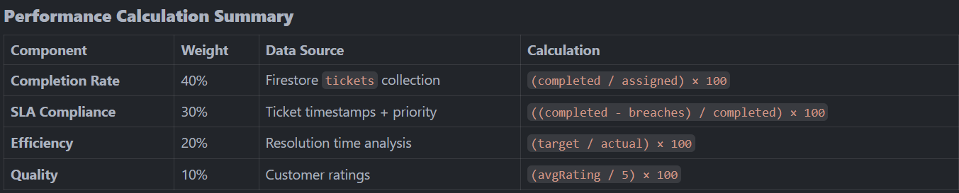  Reports section is repeated

Performance calculation Formula:
Performance% = (CompletionRate × 0.40) + (SLACompliance × 0.30) +
(Efficiency × 0.20) + (Quality × 0.10)
  - Chief Engineer Dashboard / Executive Engineer Dashboard/ Superintending Dashboard
Feature | Existing Status and WorkFlow | Updation and improvement
Regional Analytics Dashboard Section | It consists of:  - Divisions  Total Number of Divisions  - Resolution Rate  Resolution Rate (%) = (Number of Resolved Tickets / Total Tickets) × 100  - SLA Compliance  ((completed - breaches) / completed) × 100 | SLA – Service Level Agreement  (%) conveys how much the service delivered meet the user’s compliant and User is satisfied with it. Doing the expected requirement of the user.
Complaint Intensity Map Section | The Officer will get the number of complaints of specific type represented by color in the respective(any) region.  By default, violet is given for fallback if no complaints of the predefined come. Hence currently, violet is showing  It also consists of:  - Cases (Blue)  Total number of cases registered  - Regions (Green)  Number of Geographic clustered detected  - Max (Orange)  Highest complaint density in single region | One approach can be taken that the field Engineer can update the status that can be reflected it here and verified further.
Tasks Assignment Button | To redirect it to Task Management Section
Sidebar | It consists of:  - Dashboard  - All tickets  List of all complaints with a search bar  - Task Management  Explained below  - Reports  - Daily Summary  - Weekly Analysis  - Monthly Report  - Team Performance  SLA Compliance | Currently all the report tabs are not working  Ideal functionalities are enlisted below  Daily Summary  - Performance Metrics  - Tasks Completed: 5  - Tasks In Progress: 2  - Pending Tasks: 3  - Overall Completion Rate: 62.5%  - Time Analysis  - Total Hours Worked: 8.5 hrs  - Average per Task: 1.7 hrs  - Most Time-Consuming Task: Fault Repair (3.2 hrs)  - Most Efficient Task: Meter Reading (0.9 hrs)  - Cost Breakdown  - Materials Cost: ₹2,450  - Labor Cost: ₹1,020  - Total: ₹3,470  - Task List  - Expandable list of all tasks with status  - Field Observations  - Weather conditions  - Site challenges  - Safety issues encountered  Monthly Report  Dashboard Visualization:  - Line chart: Daily completion rates  - Pie chart: Task category distribution  - Bar chart: Cost vs. time comparison  - Heatmap: Task distribution across areas  Team Performance  Displays:  - Officer-wise performance table  - Rankings/leaderboard  - Individual officer profiles with metrics  - Team comparisons with targets  SLA Compliance  Compliance rate
Notification button | NOT WORKING no notification
Task Management NOT WORKING | It consists of:  - Overview  - Division Overview:  - Active Tasks  - Pending Assignments  - Completed today  - Critical Issues  - Team Management  - AE Team - <Direction> of region  - Left labels – no. of members  - Right labels – no. of active tasks in that regions  - Analytics  - Resolution Time  - SLA Compliance  - Task Efficiency  - Reports  a. Daily Summary  b. Weekly Analysis  c. Monthly Report  Explained Before |   Reports section is repeated

View Report:
Information | Details
Task ID | Unique identifier (e.g., TK-2026-001234)
Title | Task description
Category | Type of work (Power Supply, Maintenance, etc.)
Priority | High/Medium/Low
Location | Field work location with coordinates
Assigned Officer | JE/AE name who completed it
Start Time | When work began
End Time | When work completed
Duration | Total time spent (in hours)
Status | Final status (Resolved/Completed/Closed)
Description | Original problem statement
Resolution Summary | How the issue was resolved
Materials Used | Parts/equipment consumed
Cost | Labor + materials cost
Before Photos | Evidence of initial condition
After Photos | Evidence of completed work
Customer Signature | Digital signature/approval
Supervisor Notes | Any additional remarks
┌─────────────────────────────────────────────────────────────┐
│ TICKET LIFECYCLE │
└─────────────────────────────────────────────────────────────┘

[Created]
↓
[Assigned to Officer]
↓
[ACKNOWLEDGE] ← Officer confirms receipt
↓
[Acknowledged]
↓ ↘
│ [DECLINE] → Reason → [Reassigned]
↓
[UPDATE STATUS] ← Multiple updates during work
│
├→ En Route
├→ On Site
├→ In Progress
├→ Awaiting Parts
└→ Testing
↓
[UPDATE STATUS: Completed]
↓
[Supervisor Review] (optional for some roles)
↓
[MARK RESOLVED] ← Final closure
↓
[Resolved]
↓
[Customer Feedback]
↓
[Closed]

IT-ADMIN :-
Feature | Existing Status and WorkFlow | Updation and improvement
System Overview | 1 Online -> Shows the system status(Uptime/updated) = Not showing the real data()  2 Database -> Hard coded  3 Security check ->  4 Optimal performance | -
Notification | Not getting the alert message from the admin/Staff | Addition of Pop up alert
User Management | User->fake data in users , not showing the status & role  * also we should be able to edit/delete/disable  * Update the live user count with their roles and allowed permissions  * Add new user button is not working | IN user there should be 3 colums of 1 admin  2 officer  3 citizen
API Management | *To show the actual request and responce of  1 Authentication  2 Titcket  3 report  4 notification  *API keys -> No need to show and update the api keys  * API analytics are not working request vs region, request vs time
System log | Application logs, system events, error analysis -> Dummy data not working anything
Security Management
System Management | Database server,web server, api gatewats, file storage, Activity storage-> Show its connected or not  System services and parental control is not working

Hierarchy Level Officer Description with their roles and responsibilities
LEVEL 0: CHIEF EXECUTIVE
Chief Engineer (CE)
Responsibilities:
- 🎯 Strategic Planning: Set organizational goals and policies
- 📊 Enterprise Analytics: Monitor state-wide performance metrics
- 🔍 Oversight: Review all circles' operations
- 📋 Policy Making: Create guidelines and standards
- 🤝 External Relations: Liaison with government bodies
- 💼 Budget Allocation: Distribute resources across circles
Dashboard Capabilities:
- State-level analytics dashboard
- Multi-circle complaint heatmap
- SLA compliance monitoring (enterprise)
- Resource utilization across circles
- Budget tracking and forecasting
- Performance trends (quarterly/annual)

LEVEL 1: STRATEGIC MANAGEMENT
Superintending Engineer (SE)
Responsibilities:
- 📍 Circle Oversight: Manage multiple divisions
- 📊 Division Analytics: Monitor each division's performance
- 🎯 Goal Setting: Set division-level targets
- 🤝 Coordination: Facilitate inter-division cooperation
- 📈 Performance Review: Monthly/quarterly reviews
- 🔄 Resource Balancing: Allocate resources across divisions
Dashboard Capabilities:
- Circle-level analytics
- Multi-division complaint heatmap
- Division-wise performance comparison
- SLA compliance (circle-level)
- Budget distribution
- Trending analysis

Executive Engineer (EE)
Responsibilities:
- 👥 Team Leadership: Manage AEs, DyEEs, and JEs
- 📊 Division Analytics: Track all operational metrics
- 🎯 Target Setting: Set sub-division targets
- 📋 Planning: Create operational plans
- 🔍 Quality Control: Ensure work quality standards
- 💰 Budget Management: Division-level budget control
- 📈 Growth Strategy: Improve division performance
Dashboard Capabilities:
- Division-level analytics dashboard
- Sub-division complaint heatmap
- AE/DyEE team performance monitoring
- SLA compliance (division-level)
- Cost breakdown by category
- Productivity trends

LEVEL 2: TACTICAL MANAGEMENT
Deputy Executive Engineer (DyEE)
Responsibilities:
- 👥 Team Management: Oversee JEs in cluster/zone
- 📊 Performance Monitoring: Track team metrics (8 metrics)
- 🎯 Task Assignment: Assign field work to JEs
- 📍 Cluster Analysis: Identify complaint hotspots
- ✅ Quality Assurance: Review completed work
- 📈 Performance Improvement: Mentor JEs
- 🔄 Resource Coordination: Manage team resources
Dashboard Metrics:
- Active JEs: 8
- Pending Tasks: Real-time count
- Completed Tasks: Daily/weekly
- Clustered Complaints: Area-wise
- Team performance trends
- Individual JE performance
- Resource utilization
- Cost per JE

Assistant Engineer (AE)
Responsibilities:
- 👥 Sub-Division Leadership: Manage JEs in sub-division
- 📊 Performance Tracking: Monitor team productivity
- 🎯 Work Distribution: Assign tasks based on capacity
- 📍 Area Management: Oversee specific operational areas
- ✅ Supervision: Review and approve completed work
- 📈 Development: Train and mentor JEs
- 🔍 Quality Control: Ensure compliance with standards
Dashboard Metrics:
- Active JEs: 6
- Pending Tasks: Sub-division level
- Completed Tasks: Daily tracking
- Area-wise complaints
- Team productivity metrics
- Individual JE performance
- Task completion rate
- Cost analysis

LEVEL 3: OPERATIONAL EXECUTION
Junior Engineer (JE)
Responsibilities:
- 🔧 Field Operations: Execute assigned field work
- ⚡ System Verification: Check SCADA status before work
- 📊 Progress Tracking: Update task status regularly
- 📸 Documentation: Capture evidence (photos, notes)
- 🎯 Task Completion: Complete assigned work on time
- 🔄 Communication: Report issues to supervisors
- 📍 Location Accuracy: Work in assigned areas
Dashboard Capabilities:
- SCADA Verification Panel
  - Feeders status (12/15 active)
  - Substations status (8/8 online)
  - Weather conditions (Clear)
  - Pre-work safety checks
- Today's Field Work Progress
  - Line Inspection: 70% complete
  - Meter Reading: 90% complete
  - Fault Repair: 30% complete
  - Real-time progress bars
- My Tasks Management
  - View assigned tasks
  - Update task status
  - Add progress notes
  - Upload photos
  - Mark tasks as complete

Complete Officer Hierarchy Structure
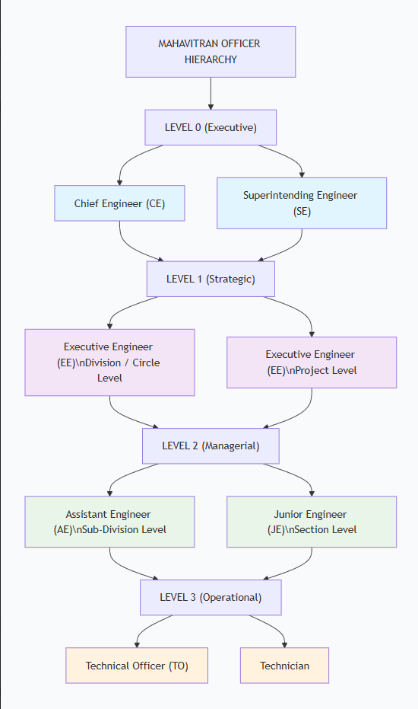
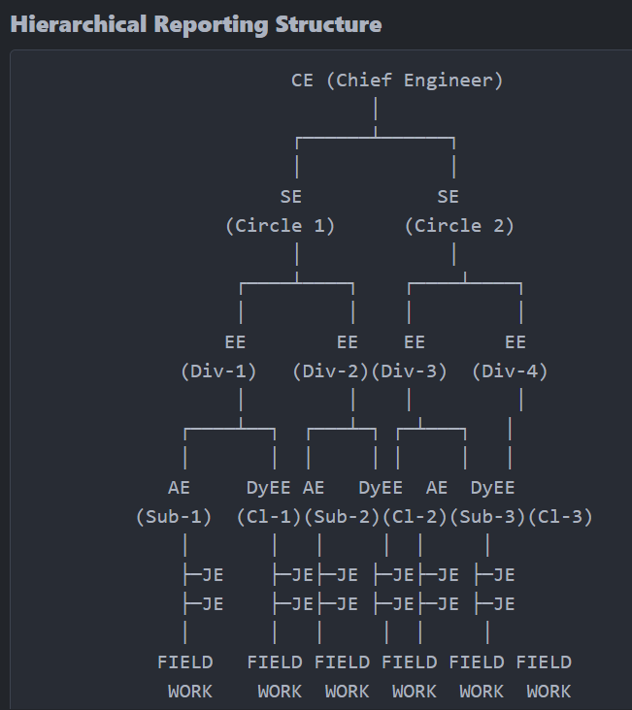
Dashboard Type Distribution
TYPE 1: FIELD OPERATIONS (JE)
├─ SCADA Verification Panel
├─ Today's Field Work Progress
└─ My Tasks Management

TYPE 2: MANAGEMENT (AE/DyEE)
├─ Team Performance Overview
├─ Clustered Complaints
├─ Task Assignment
└─ Team Member Monitoring

TYPE 3: STRATEGIC ANALYTICS (EE/SE/CE)
├─ Regional Analytics Dashboard
├─ Complaint Intensity Map (Heatmap)
├─ SLA Compliance Metrics
├─ Predictive Analytics
├─ Budget & Resource Planning
└─ Enterprise Reporting

Role Comparison Matrix
Aspect | JE | AE/DyEE | EE | SE | CE
Dashboard Type | Field Ops (1) | Management (2) | Strategic (3) | Strategic (3) | Strategic (3)
Scope | Individual | Team (6-8) | Division (20+) | Circle (50+) | Enterprise (100+)
Primary Focus | Field Work | Team Mgmt | Division Mgmt | Circle Mgmt | Enterprise Mgmt
Reports To | AE/DyEE | EE | SE | CE | Board/Ministry
Task Management | Execute | Assign | Oversee | Monitor | Strategic
Analytics | Daily Personal | Team Weekly | Division Monthly | Circle Quarterly | Enterprise Annual
Budget Control | N/A | Sub-div | Division | Circle | Enterprise
Authority Level | Individual | Sub-div | Division | Circle | Enterprise
Approval Rights | Self-report | Team tasks | Division plans | Circle strategy | Enterprise policy

Data Access Hierarchy
CE ────────→ Can view entire state data
↓
SE ────────→ Can view circle data + divisions
↓
EE ────────→ Can view division data + sub-divisions
↓
DyEE/AE ───→ Can view cluster/sub-division data + JE teams
↓
JE ────────→ Can view only assigned tasks & personal metrics

